Moon

I. Remember that he’s real.
Just like us.

II. He is home to something
maybe billions of aliens.
Treat their home like art in a museum.
Don’t touch.

III. He shines bright
for you in complete darkness.
Thank him.

IV. Though you fear leaving
this earth forever,
accept him.
Join the moon as a star.

V. He is your only friend
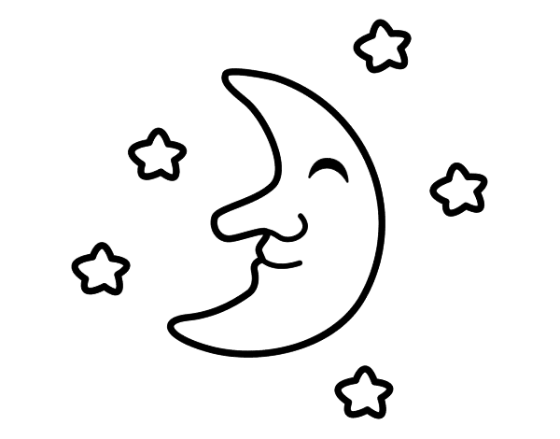
at 2 AM.

